IELTS Speaking structure
IELTS Speaking is a one-to-one interaction between the candidate and an examiner. The three parts give the candidate the opportunity to use a range of different speaking skills. IELTS Speaking is recorded.
Timing
11 – 14 minutes
Marking criteria for IELTS speaking
- Fluency – talking at length, talking without pauses or hesitations, talking without self correction, able to be understood, using linking devices
- Lexical resource – using a range of words & paraphrasing, using collocations, using less common vocabulary, avoiding errors
- Grammar range & accuracy – using a range of sentence structures, using a range of grammar tenses, avoiding errors
- Pronunciation – able to be understood throughout the test, able to use intonation, accent does not affect understanding,

IELTS Tips advice suggestions- Speaking
1. Give a full answer. Don't just give one word answers. Include more information. For example, when asked where you're from, instead of just saying the name of the place, speak in a sentence which states the name, the location, and how long you've been there. This shows the examiner you are confident speaking in English. But don't speak too long or the examiner will think you've misunderstood the question!
2. Speak clearly and don't worry about your accent. Everyone has an accent when they speak English. The important point is that you enunciate the best you can so the examiner can understand you. Rehearse in advance to overcome any obvious pronunciation problems. If you make a mistake, don't worry, just correct yourself and keep going.
3. Use descriptive words. Don't use boring words like good, bad, nice, or okay. Use exciting words that covey emotion. Practice using higher level words for every simple word you know – such as thrilled instead of happy, or depressed instead of sad.
4. Speak up. Sometimes, students mumble and speak very softly because they are nervous or unsure of their words. Use simple, correct language rather than complicated vocabulary and speak loudly enough that the examiner does not have to strain to hear you. This indicates self-confidence and command of the language.
5. Don't use slang. You have 11 minutes to display the best English you know in all the years that you have been learning English! Choose to be formal rather than informal.
6. Keep a steady pace. Don't speak too fast or too slow.
7. Don't try to memorize answers to sample subjects. The examiner has enough experience to recognize that you are not speaking naturally and spontaneously and will change the subject or give you a lower score. Use the sample subjects to give you practice speaking on a variety of topics, but not to memorize.
8. Explain names or words which are in another language. For instance, if you are asked to speak about a festival, which involves using words in your language, say the words clearly and give the meaning if any afterwards, so the examiner can follow your explanation.
9. Ask questions, if necessary, in Part 3 only. You cannot ask questions in Parts 1 and 2, but you can do so, if necessary in Part 3.
10. Practice speaking with a watch. Get an idea of how long two minutes is and approximately how much content you will have to cover.
11. Stay on topic. Don't change the subject or the examiner will think you have misunderstood and may give you a lower mark.
12. Have daily discussions with friends. Take turns asking each other questions about current events and develop your ability to speak about various topics, using varied sentence structure and vocabulary

- In Speaking, don’t try to give a prepared speech, or talk about a different topic from the one you are asked to discuss.
- Always speak directly to the Examiner, not to the recording equipment.
- Whenever you reply ‘Yes’ or ‘No’ to the Examiner’s questions, add more details to your answer. In each case, aim to explain at least one point.
- Remember that you are not being tested on your general knowledge but on your ability to communicate effectively.
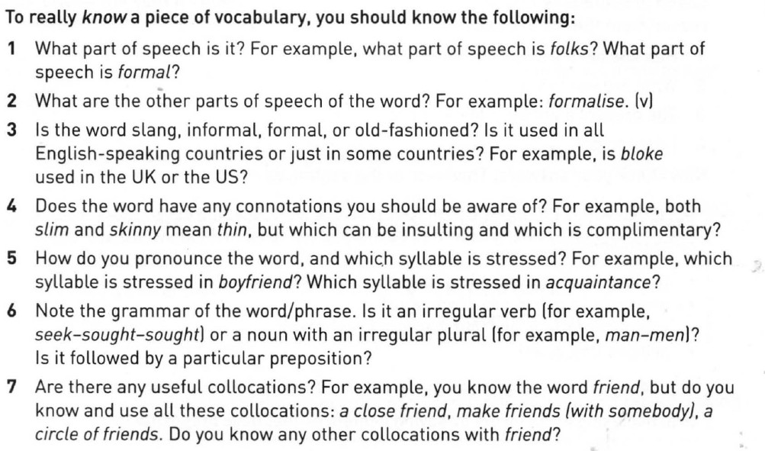
If there's a word that you don't understand, you can say:
- Could you repeat X, please?
- What does X mean?

If you didn't hear properly, you can say:
- Sorry, I didn't catch that.
- Could you repeat the question, please?

How to maximize the score
You need to extend your answer with some details.
Relative pronouns and relative adverbs.
Put them in the middle of the sentence
Who – to describe people. The person I went to school to who is now a famous movie star.
That – to describe things. I went to a bar on Sunday that a fantastic place to visit.
Which – The film, which I saw on Saturday, was really good.
Whose – to describe possession. The car I drove whose owner is Charlie.
Adverbs
When – talking about time
I went to school when I was aged 7 to 18
Where – talking about place
I went to the actor’s temple where I learnt a lot about acting

I went to school with Charlie who is now a movie star.
The man who helped me pass my driving test now lives in London
I played football at school which was fun.
The teacher whose expertise helped me pass my exam.

\
I really like the girl _________ sells cake at the market.

which
whom
who
whose

Use 'who' when describing people doing something - the subject(s) of the verb.

2. I know a man __________ cat turned into a leopard.
whose
which
whom
with
We use 'whose' to show possession.

3. I've decided to sell the cricket bat _________ I was given for Christmas.
which
that
whom
whose
'That' is used to describe things, when the extra information is a defining relative clause.

4. Combine the following sentences into one sentence using a relative pronoun.
Yesterday I spoke to a policeman.
He was handcuffing someone at the time.
Yesterday I spoke to a policeman which was handcuffing someone at the time.
Yesterday I spoke to a policeman that was handcuffing someone at the time.
Yesterday I spoke to a policeman who was handcuffing someone at the time.
Yesterday I spoke to a policeman whom was handcuffing someone at the time.

5. Combine the following sentences into one sentence using a relative pronoun.
I sold the car to a Spanish man.
His name was Juan.
I sold the car to a Spanish man which name was Juan.
I sold the car to a Spanish man whose name was Juan.
I sold the car to a Spanish man whom name was Juan.
I sold the car to a Spanish man that name was Juan.

6. Combine the following sentences into one sentence using a relative pronoun:
I'm selling the car.
I bought it in Los Angeles.
I'm selling the car when I bought in Los Angeles.
I'm selling the car whom I bought in Los Angeles.
I'm selling the car where I bought in Los Angeles.
I'm selling the car that I bought in Los Angeles.
The meaning here is that I could have more than one car, but I am being specific about the car that I am selling. Therefore, I use 'that' and a defining relative clause.

7. Combine the following two sentences using a relative pronoun:
I'm selling this dress.
I bought it in London.

I'm selling this dress, which I bought in London.
I'm selling this dress, whom I bought in London.
I'm selling this dress that I bought in London.
I'm selling this dress, who I bought in London.

'Which' is used for non-defining relative clauses - phrases that add information but are not essential to the sentence. Use a comma before a 'which' phrase, but not before 'that'.

8. Choose the sentence with the correct word order
.
When I'm having an ice cream I get to the beach!
I'm having an ice cream when I get to the beach!
I'm having an ice cream I get to the beach when!
I'm having when an ice cream I get to the beach!

9. Choose the sentence with the correct word order.

I'm going where to an island the sun shines brightly every day.
I'm going to an island the sun shines brightly where every day.
I'm going to an island where the sun shines brightly every day.
I'm going to an island the sun shines brightly every day where.

10. Choose the sentence with the correct word order.

Do you know why you are doing a quiz?
Do you know you are doing a quiz why?
Do you know you are doing why a quiz?
Do you know you why are doing a quiz?

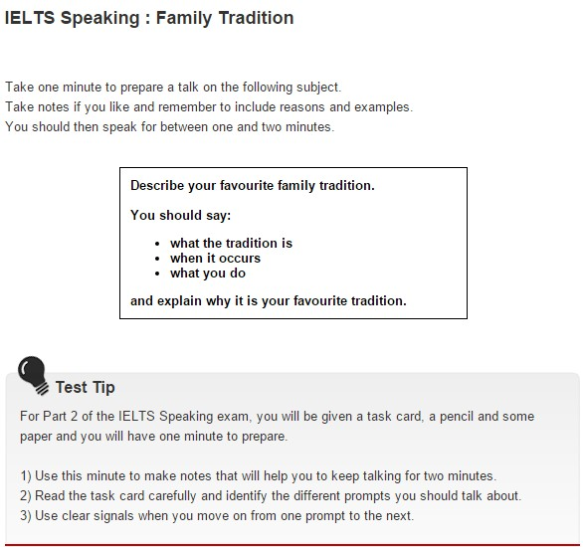

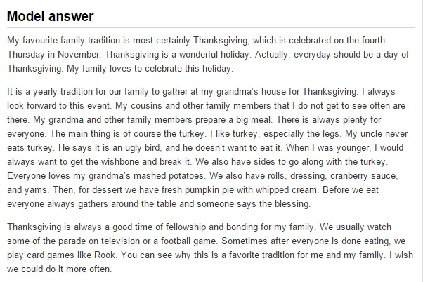

IELTS Speaking : Free Time
- What do you enjoy doing in your free time?
- How much time do you have each week for doing these things?
- Why do you like doing these activities?
- How did you start doing this activity at first?
- Is there some other hobby or sport you would like to try? Why?
- How has the way people spend their free time changed over the years?

Model answer 1

Well, I do quite a lot of sport actually. I go swimming twice a week. There’s a very good pool just around the corner from my office. I swim for an hour and do about 40 lengths. I also cycle to work when I can. Apart from that, I do a lot of reading and photography.

Model answer 2

When I was younger, I did a lot of surfing. I used to go snowboarding quite often too in the winter. But I haven’t been for a long time, although I might go this year with some friends. These days I go cycling when I can. At the weekends I like to cook and invite friends around for dinner. I’m a big fan of cooking programs, and often try to copy the recipes, but they don’t always turn out very well.

Model answer 3

I don’t have a lot of time to myself now that I’m married with two young children. So, a lot of my free/leisure/spare time is used taking my kids to their activities. For example, on Saturday morning, I have to take my son to his basketball games, and my daughter to football practice. Then I have to ship them off to parties or friends’ houses. Two or three times a month, my wife and I go for a meal with friends, and once a month, we go the cinema when my parents look after the kids. There’s a great little cinema that shows independent or foreign films just near where we live.

Model answer 4

I have tennis lessons with a group of friends at the weekend. There are eight of us, four moms and dads and four kids. The idea was that the lessons would give us the chance to do something sporty with our children, and it’s great. The teacher is really good and we all have a fantastic time. Plus, we’re getting better at tennis. Best of all, after an hour of tennis, the kids go off to play, and we can have a drink and a chat. Now, that’s my idea of playing sport. Apart from that, I also go out bowling once a month.

Model answer 5

I play golf at the weekend. I get up really early on Sunday and play for about five hours with some friends from work. While I’m out, my husband prepares lunch which is usually ready by the time I get back. Apart from that, I play online video games and read a lot. Also, I go for a drink after work every Friday with my work colleagues. There’s a pub nearby and we usually stay there for a couple of hours, which is good fun.

IELTS Speaking : Describing Places
Take one minute to prepare a talk on the following subject.
Take notes if you like and remember to include reasons and examples.
You should then speak for between one and two minutes.
Describe a place that you enjoy visiting.
You should say:
- where the place is
- what you can see and do there
- how it has changed since you first visited it
and explain why you enjoy visiting this place.

IELTS Speaking Tip
Listen carefully to the examiner’s questions to make sure that you answer them fully and appropriately. Don’t be too shy to ask for help in the interview if you need it.

Model answer
A place that I enjoy visiting is Prague. It’s the capital and largest city of the Czech Republic, with a population of nearly 2 million. It lies in the north-west of the country, in the centre of the Bohemian region, which is a green and lush part of Czech Republic.
There is lots to do in Prague. It has several universities, so first and foremost it’s a fantastic place to be a student. It’s buzzing, with a good nightlife, good restaurants and a lively cultural life. In fact, it’s a UNESCO World Heritage Site and a cultural and economic centre of central Europe a few years back.
If you climb up to the hill overlooking the old town, you have an amazing view of the city. What strikes/surprises me most when I go up there is all the traditional, pale buildings with their red roofs, and then right in the middle of it all, a remarkable piece of art and engineering, the Charles Bridge. It is one of the most loved attractions in Prague that crosses the Vltava River. It was built between the 14th and 15th centuries and connects Prague Castle with the Old Town. Today you can walk across it and find many souvenir stalls or have your caricature drawn. There are many statues on the bridge and some people think that if you touch the statue of St John of Nepomuk you will receive good luck and return to Prague soon.
The last time I went to Prague, they were having a wine festival. People were tasting all kinds of wines from stalls on the street, very informally and chatting with friends while they drank. It was wonderful.
How has it changed since I first visited it? Well, I would say it has undoubtedly become more trendy. Like I say, they have built a stunning new museum. Another example is “the Lennon Wall”, a monument of recent vintage: It is a wall covered in graffiti and pictures inspired by John Lennon and the Beatles. People have been drawing on the wall since the 1980s and they continue to do so today. I would say the local inhabitants have become more overtly proud of their city too. It has received quite a bit of recognition in recent times, which has really placed Prague well and truly on the cultural map; something the inhabitants are always happy to talk to you about. In fact, that is something else I enjoy about going there: the local people are invariably friendly and helpful.
When did you last go to Prague?
I last went there the year before last. I wish I could go more often, but unfortunately work commitments mean I can’t.

IELTS Speaking : Childhood
Take one minute to prepare a talk on the following subject.
Take notes if you like and remember to include reasons and examples.
You should then speak for between one and two minutes.
Describe a happy childhood memory.
You should say:
- when and where the incident you remember happened
- who you were with
- what happened exactly
and explain why it is a happy memory.

IELTS Speaking Tip piece of advice, recommendation
To get maximum benefit all the practice should be done without preparing your answers. You will not know exactly what the examiner is going to ask or exactly how he or she will ask it. You need to be spontaneous, to speak as naturally and fluently as possible. The aim of this practice section is to help you to prepare for the type of questions you will get and to practise dealing with them without preparing specific answers. It is important to keep to this for two reasons. First, the examiner will notice if you are repeating something you have learned and will stop you. Second, though it may seem difficult at first, it will actually make the test easier for you if you relax and talk naturally rather than trying to remember a ready-made answer. So the first and most important skill is talking fluently.
The only way to improve your fluency is by getting a lot of practice in speaking. Be confident. Think about what you want to say. Of course you should try to get your English right, but do not worry too much about getting everything absolutely correct. The important thing is that you should speak and listen, that you should engage in an extended interview with the examiner and that you should enjoy using your English to communicate with an English speaker. Most of the exercises in this section are designed to increase your fluency.

Model answer

I grew up very far from most of my family so I only saw them once a year. Every summer I would go to stay with them, while my parents continued working. Although I missed my parents, I used to really enjoy spending time with my grandparents, cousins, aunts and uncles. I spent all summer there, nearly two whole months, so from time to time my cousins and I would get bored. We would ask my grandparents if they had any ideas for interesting things we could do. Sometimes they suggested going for a bike ride, sometimes into town to do some shopping. At other times, they showed us a new game to play. Then we were happy again.
One day - it must be about 30 years ago (doesn't time fly!) - all of us got really, really bored and we kept complaining to my grandparents. They were tearing their hair out, trying to think up ideas of where we could go and what we could do. Suddenly, my granddad came up with the idea of going to a new water park that had opened that summer. I hadn't heard about it but my cousins had, and they told me all about it. It was a park with vast numbers of different pools, some inside, some outside. There were water slides as well. And, on top of there was not one, but two playgrounds with swings, a merry-go-round, see-saws. We were so excited.
We set off and on the way we were all singing songs and laughing. We couldn't wait to get there. When we arrived, my cousins and I ran into the park and changed into our swimming costumes. Then we went looking for the most exciting-looking pool, and we found it, one with brightly coloured tiles and slides, we jumped straight in. We played all day in the park and had a lovely lunch, sat on some benches in the sunshine.
My granddad loved a pool that was filled with spa water. It was dark brown and stank of rotten eggs. I didn't want to go in but he eventually convinced me. I'm pleased he did because the water was really warm. I'd never swam in water that warm. I didn't want to get out, despite the terrible smell.
I consider it such a happy memory because we enjoyed ourselves so much and I remember so vividly how I felt that day. But there's more to it than just that. When I look back now, I understand how caring my grandparents were and how much they wanted us all to be happy. They would have done anything to help us have a good time. I appreciate that more now that I'm older and have children of my own. I hope we thanked them; I can't remember. But, anyway, they were content, I'm sure, to just watch us have an amazing time, playing and laughing in the water. So, as you can see, it was a wonderful day and is one of my favourite childhood memories.
What other activity did you use to enjoy when you were staying with your family?
I loved going for walks in the local park. There were people selling all kinds of delicious foods from carts, so my grandparents would invariably buy us some treat, like homemade ice-cream or cakes

Performance is assessed on the following criteria:
Fluency and Coherence: Do you express ideas and opinions clearly and coherently, without long hesitations?
Lexical Resources: Do you use a wide range of vocabulary?
Grammatical Range and Accuracy: Do you use a wide range of structures and make only a few minor mistakes?
Pronunciation: Are you easy to understand? Do you use English pronunciation features naturally?

What can I do to improve my performance at the Speaking test?
- Be relaxed and try to be friendly. Remember the examiner is trying to find out what you know, not what you don’t know.
- You can ask the examiner to repeat the question if you did not understand it the first time.
- Record yourself or practice speaking on a variety of topics for 1 – 2 minutes. This will help you gain confidence and practice time management.
- Vocabulary - don’t use unfamiliar, long words if you are not sure of their meaning.
- If you cannot remember the exact word you want, paraphrase and try to express your idea using similar words.
- Practice making notes, spider-grams, and mind maps which will help you to talk on various topics in one minute.
- Try to develop your answers instead of answering in just one word. Speak loudly and clearly into the recorder.
- Avoid using slang and abbreviations.
- Please do not tell the examiner what grade you require or ask how well you have done. This will only cause embarrassment.
- Do not use memorised chunks of language. Examiners are trained to recognise this. Furthermore, what you have memorised may not be relevant to the topic being discussed.

Talking about home towns
- Are you here (in your host country) alone?
- Do you like living in this country / your home town?
- What do most teenagers like doing in your country?
- When did you set up house?
- Have you met your next-door neighbours yet?
- Is there a supermarket in the neighbourhood (where you live)?
- Are you a native of Aberdeen?
- Would you like to move house to a bigger area?
- Can you get along with your neighbours?
- When did you settle in this town?
- What are some of the problems of urban life?
- Would you like to be inhabitant of a small village?
- Which part of town do you live in?
- Have you ever lived in the suburbs?
- Do you like living in the centre of a big city?
- What social problems do you think we have in your society?
- How do you define a good society?
- Do you consider your home town as a cultural spot?
- What are the cultural values of your country?
- Do you like living in a multicultural society?
- How do you define a traditional society?
- What makes an advanced industrial society?
- Do you belong to a very close community who would find it difficult to accept too many newcomers?
- Are there many different social classes of people in your country?
- Do most people in your country own their house? Why (not)?
- Is it easy to find accommodation in your home town?
- What kind of place are you living in at the moment?
- Who do you live with and why?
- Are there any advantages of living where you are at present? What are they?
- Can you describe your study room / bedroom to me?

Speaking part 1
In part 1 of the Speaking test the examiner will introduce him or herself and ask general questions on familiar topics.
The examiner will ask you to confirm your identity.
He or she will then ask general questions on familiar topics such as home, family, work, studies and interests. Part 1 of the test will last 4-5 minutes.

How to practise
You will need a study partner to practise the Speaking test.
Ask your study partner to interview you using the questions below. Record yourself if you can.

Speaking test part 1: questions
Let’s talk about your home town or village:
- what kind of place is it?
- what’s the most interesting part of your town/village?
- what kind of jobs do the people in your town/village do?
- would you say it’s a good place to live? (why?)
Let’s move on to talk about accommodation:
- tell me about the kind of accommodation you live in?
- how long have you lived there?
- what do you like about living there?
- what sort of accommodation would you most like to live in?

Speaking part 2
In the IELTS speaking part 2 test you will be given a task card on a particular topic, and this will include key points that you should talk about.
This section of the Speaking test gives you the opportunity to speak for longer on a topic.
You will be given one minute to prepare to talk about the topic on the task card. A pencil and paper will be provided for you to make notes.
You will have to talk for 1-2 minutes, and then the examiner will ask you one or two questions on the same topic. Part 2 takes 3-4 minutes in total.

How to practise
Ask your study partner to listen while you speak about the task card topic. You should talk for 1-2 minutes.
Your study partner should then ask you one or two questions on the same topic using the rounding off questions.
Record yourself if you can.

Speaking test part 2: candidate task card
Describe something you own which is very important to you.
You should say:
- where you got it from
- how long you have had it
- what you use it for; and
- explain why it is important to you.
You will have to talk about the topic for 1 to 2 minutes.
You have one minute to think about what you're going to say.
You can make some notes to help you if you wish

Part 3

Attitudes to tourism
- Why do you think people like to travel to different places in their free time?
- How do you see tourism changing in your country in the future?

Conserving the countryside
- Why is it important to protect the countryside?
- In what ways is the countryside in danger in your country?

Historic buildings and monuments
- Why are historic buildings and monuments important to a city?
- Is it better to keep old buildings, or build new modern ones?

How to practice

- About you
- Study
- Work
- Your town
- Free time
- Holidays
- Places to go in your free time
- Transport
- Shopping
- Your neighbourhood
- Reading
- Sports and games

About you

- What is your (full) name?
- Can I have your name please?
- Could you tell me your full name please?
- What shall I call you?
- How can I address you?
- Does your name have any special meaning?
- Is your name important to you?
- Do Korean people like changing their name? Why?
- Have you ever changed your name? Why or why not?
- Why do so many people change their name?
- Do you work or study?

Study

- What are you studying?
- What’s your major?
- Why did you choose that subject?
- What do you find most interesting about your course?
- What is your favorite subject?
- What do you dislike about your study?
- What do you hope to do after your graduation?
- What are your ambitions for the future?
- Do you hope to gain any qualifications?
- What are the advantages of studying instead of working?

Work

- Can you describe your job to me?
- What do you do for a living?
- How long have you been doing it?
- Can you describe one of your typical working days?
- What’s your daily routine on a working day?
- Why did you choose to do that job?
- What things do you enjoy about your work? Why?
- What do you think is the attraction of your work?
- What is your ideal job?
- Do you want to change your current job? Why or why not?
- Are you willing to keep your job permanently?
- What are your plans for the future?

Your town

- Can you describe your town or village to me?
- Tell me something about your hometown.
- Where are you from?
- Where is your hometown?
- Where do you come from?
- What is the name of the street you live on?
- What kind of street do you live on?
- What do you like about your town?
- What is the weather like in your town?
- What building is considered famous in your town?
- What jobs do people in your town do?
- How has your town changed over the last twenty years?
- What changes have taken place in your city in recent years?
- Do you think it is better to live in the center of town or outside in the country? Why?

Free time

- What do you enjoy doing in your free time?
- How much time do you have each week for doing these things?
- Why do you like doing these activities?
- How did you start doing this activity at first?
- Is there some other hobby or sport you would like to try? Why?
- How has the way people spend their free time changed over the years?

Holidays

- What do you do when you have a holiday?
- Who do you usually spend holiday with?
- Where do you like to spend your holidays? Why?
- Can you describe a typical day in your holidays?
- Why are holidays and important to you?
- If you could take a holiday anywhere in the world, where would you go? Why?
- What do people usually do during holidays and in your town?

Places to go in your free time

- What do people do in your town in their free time?
- Where can they go out for entertainment, or to enjoy themselves?
- Which do you prefer: eating in restaurants or eating at home?
- Which are the best places to eat out?

Transport

- How did you come here today?
- What is public transport like in your town?
- How do you think it could be improved?
- Do you think people should use public transport more? Why (not)?

Shopping

- How much time do you spend shopping every week?
- Do you enjoy going shopping? Why (not)?
- What is your favourite shop and why do you like it?
- What problems are there with shopping in your area?

Your neighbourhood

- Can you describe the house where you live to me?
- What is there to do in the area where you live?
- What do you like about the area where you live?
- How do you think it could be improved?
- Do you think it is better to live in the centre of town or outside in the country? Why?

Reading

- Do you enjoy reading? Why?
- What sort of things do you read?
- Tell me something about your favourite book.
- What are the advantages of reading instead of watching television or going to the cinema?

Sports and games

- What sports are most popular in your country?
- What sports and games did you most enjoy playing
- when you were a child?
- Do people take as much exercise as in the past?
- Why is exercise good for you?

Practice test

Part 1
Answer the questions:
- Which part of your country do most people live in?
- Tell me about the main industries there.
- How easy is it to travel around your country?
- Has your country changed much since you were a child?

Part 2
You will have to talk about the topic for one to two minutes.
You have one minute to think about what you’re going to say.
You can make some notes to help you if you wish.
Describe a well-known person you like or admire.
You should say:
- who this person is
- what this person has done
- why this person is well known
and explain why you admire this person.

Part 3
Answer these questions related to famous people:

Famous people in your country
- What kind of people become famous people these days?
- Is this different from the kind of achievement that made people famous in the past?
- In what way?
- How do you think people will become famous in the future?

Being in the public eye
- What ate the good things about being famous? Are there any disadvantages?
- How does the media in your country treat famous people?
- Why do you think ordinary people are interested in the lives of famous people?

